**Creating**

**an**

**Authorization Profile**

**In WEXOnline**

This document will walk you through the procedure to create an Authorization Profile to limit the WEX Fuel Card purchases. Once you create the profile, you will need to assign that profile to each vehicle that will use it. This change will take place immediately.

**NOTE: If you assign a profile for a vehicle that is different type of card than the current card type assigned for the vehicle you will need to issue a new fuel card. For example, if the current Authorization Profile for a vehicle is “Fuel Only” and you create an Authorization Profile that allows for non-fuel purchases, or vice versa, you will “have” to issue a new fuel card for that vehicle to use during the emergency situation. However, you may choose to create both a “Fuel-Only” and a “Custom Control” profile so you can just match the type of profile with the existing profile the vehicle is using. This will save you from having to reissue a new fuel card.**

Below are the steps to create a new Authorization Profile.

Creating an Authorization Profile:

1. Log into WEX Online
2. On the black menu bar, hover over the “**Fleet Manager**” menu option and under the “**Auth Profiles**” menu, click on “**Add Auth Profile**”
3. On the next screen, select either “**Fuel Only**” or “**Custom Control**” for card type.
4. 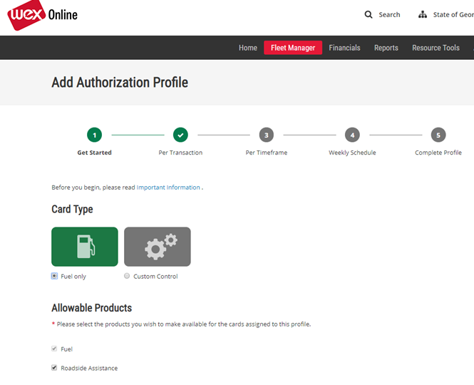Under “**Allowable Products**”, the “**Fuel**” box is already checked, so decide if you want this profile to also include “**Roadside Assistance**”. If so, check the box for Roadside Assistance.
5. Next step is to add any Limits Per Transaction
6. 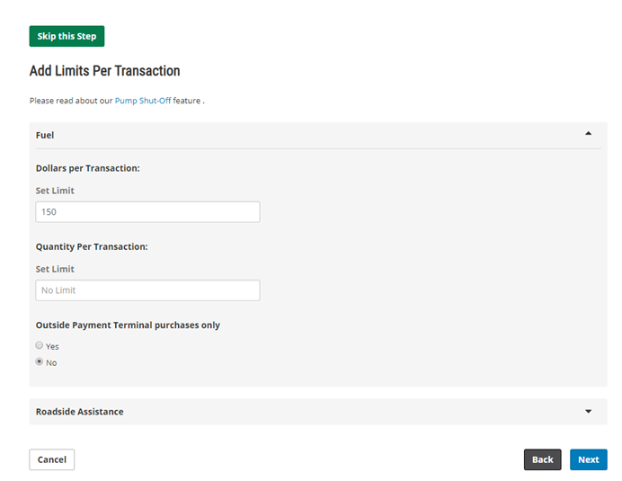“**For Dollars Per Transaction:**”, put in the amount per transaction you want to allow for fuel purchases.
7. For “**Quantity Per Transaction:**”, put the amount in gallons you want to restrict the purchases for.

***NOTE: You may want to consider just keeping the default to “No Limit”.***

1. For “**Outside Payment Terminal purchases only**”, keep the default to “**No**” to allow purchases for either inside or outside pumps.
2. Click the “**Next**” button.

The next screen will allow you to limit your transactions by timeframe.

You will need to answer the following questions:

* Would you like to limit purchases daily? “**Yes or No**”.
* Would you like to limit purchases by a different timeframe? “**Yes or No**”.

Now you may select limits by Timeframe.

F**uel**

**Dollars Per Day**

1. If you want to put a dollar amount limit for Dollars Per Transaction, in the “**Set Limit**” field, put the dollar amount you would like the limits to be per day.

**Transactions Per Day**

1. If you want to put a limit on the number of transactions per day, in the “**Set Limit**” field under “Transactions Per Day”, put the number of transactions you would like to put as a limit. The default is “3”.

**Units Per Day**

1. If you would like to limit the number of gallons per day that the vehicle may purchase, in the “**Set Limit**” field under the “**Units Per Day:**” section, put the number of gallon limit you would want.

***NOTE: you may leave blank if no limit is being placed for that section.***

1. Click the “**Next**” button

On the next screen, you may select days and timeframes when transactions can occur. Time is based on transaction location.

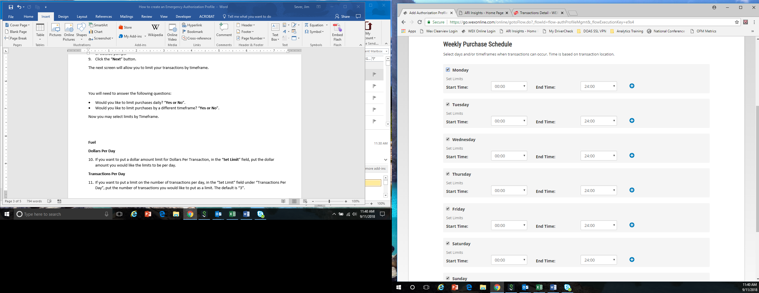

The default is all days and times are checked to allow for purchases 7 days a week, 24 hours a day. However, if you may adjust these based on your operation by just unchecking the box on the appropriate day and selecting the appropriate times. NOTE: the times are displayed in military time.

1. Click the “**Next**” Button.

On the next screen, you can Review and Save your profile.

1. For Authorization Profile Name, put in the name you want to call the Authorization Profile.
2. Click the “**Finish**” Button. This will save the profile until you need to use it.
3. Once the profile has been created, you will need to assign the profile to each vehicle that use this profile.